Week 09 Penetration Testing Report

Introduction

This report document hereby describes the proceedings and results of a Black Box security assessment conducted against the Week 9 Labs. The report hereby lists the findings and corresponding best practice mitigation actions and recommendations.

1. Objective

The objective of the assessment was to uncover vulnerabilities in the Week 9 Labs and provide a final security assessment report comprising vulnerabilities, remediation strategy and recommendation guidelines to help mitigate the identified vulnerabilities and risks during the activity.

2. Scope

This section defines the scope and boundaries of the project.
Application Name | {SQL Injection}

3. Summary

Outlined is a Black Box Application Security assessment for the Week 9 Labs.

Total number of Sub-labs: 12 Sub-labs

High | Medium | Low
4 | 4 | 4

High - Number of Sub-labs with hard difficulty level
Medium - Number of Sub-labs with Medium difficulty level
Low - Number of Sub-labs with Easy difficulty level

1. {SQL Injection}

1.1. {Strings and Errors Part1!}

Reference | Risk Rating
Strings and Errors Part1! | Low
Tools Used
Google Chrome, Burp Suite, SQL injection tool
Vulnerability Description
I found this vulnerability by entering malicious sql injection code into user input fields and successfully found user input fields vulnerable.
How It Was Discovered
Automated Tools and Manual Analysis were both used to find this vulnerability.
Vulnerable URLs
https://www.bugbountyhunter.org/internship_labs/HTML/sqli_lab/lab_1/lab_1.php
Consequences of not Fixing the Issue
Stealing credentials, access to the database, altering or modifying data, access to the network.
Suggested Countermeasures
Using stored procedures instead of dynamic SQL, prepared statements, least privilege access and input validation, character escaping, vulnerability scanner, firewall.
References
https://owasp.org/www-community/attacks/SQL_Injection

Proof of Concept
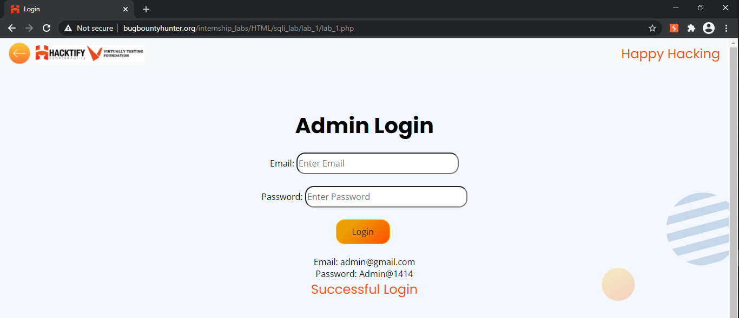

1.2. {Strings and Errors Part2!}

Reference | Risk Rating
Strings and Errors Part2! | Low
Tools Used
Google Chrome, Burp Suite, SQL injection tool
Vulnerability Description
I found this vulnerability by entering and manipulating the URL by malicious SQL code.
How It Was Discovered
Automated Tools and Manual Analysis were both used to find this vulnerability.
Vulnerable URLs
https://www.bugbountyhunter.org/internship_labs/HTML/sqli_lab/lab_2/lab_2.php/?id=1%27%20or%20%271%27=%271%20+
Consequences of not Fixing the Issue
Stealing credentials, access to the database, altering or modifying data, access to the network.
Suggested Countermeasures
Using stored procedures instead of dynamic SQL, prepared statements, least privilege access and input validation, character escaping, vulnerability scanner, firewall.
References
https://portswigger.net/web-security/sql-injection

Proof of Concept

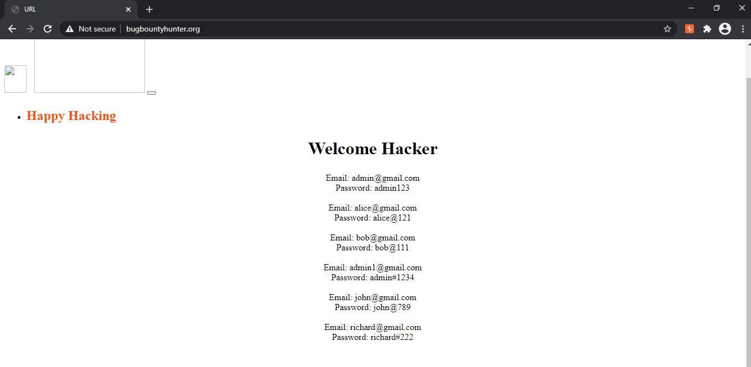
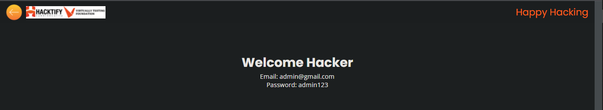

1.3. {Strings and Errors Part3!}

Reference | Risk Rating
Strings and Errors Part3! | Low
Tools Used
Google Chrome, Burp Suite, SQL injection tool
Vulnerability Description
I found this vulnerability by entering and manipulating the URL by malicious SQL code.
How It Was Discovered
Automated Tools and Manual Analysis were both used to find this vulnerability.
Vulnerable URLs
https://www.bugbountyhunter.org/internship_labs/HTML/sqli_lab/lab_3/lab_3.php?id=1%27%20or%20%271%27=%271++
Consequences of not Fixing the Issue
Stealing credentials, access to the database, altering or modifying data, access to the network.
Suggested Countermeasures
Using stored procedures instead of dynamic SQL, prepared statements, least privilege access and input validation, character escaping, vulnerability scanner, firewall.
References
https://owasp.org/www-community/attacks/SQL_Injection

Proof of Concept
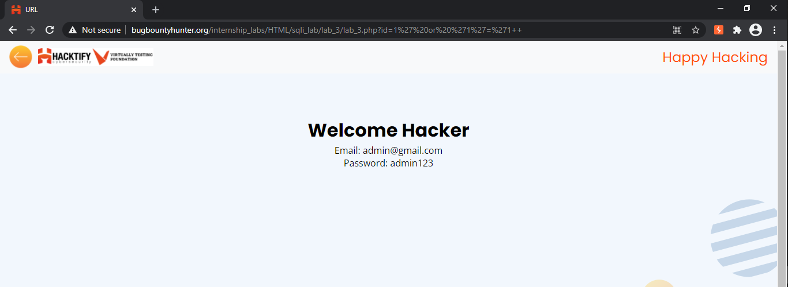

1.4. {Let’s Trick ‘Em!}

Reference | Risk Rating
Let’s trick ‘Em! | Medium
Tools Used
Google Chrome, Burp Suite, SQL injection tool
Vulnerability Description
I found this vulnerability by entering and manipulating the URL by malicious SQL code.
How It Was Discovered
Automated Tools and Manual Analysis were both used to find this vulnerability.
Vulnerable URLs
https://www.bugbountyhunter.org/internship_labs/HTML/sqli_lab/lab_4/lab_4.php
Consequences of not Fixing the Issue
Stealing credentials, access to the database, altering or modifying data, access to the network.
Suggested Countermeasures
Using stored procedures instead of dynamic SQL, prepared statements, least privilege access and input validation, character escaping, vulnerability scanner, firewall.
References
https://portswigger.net/web-security/sql-injection

Proof of Concept
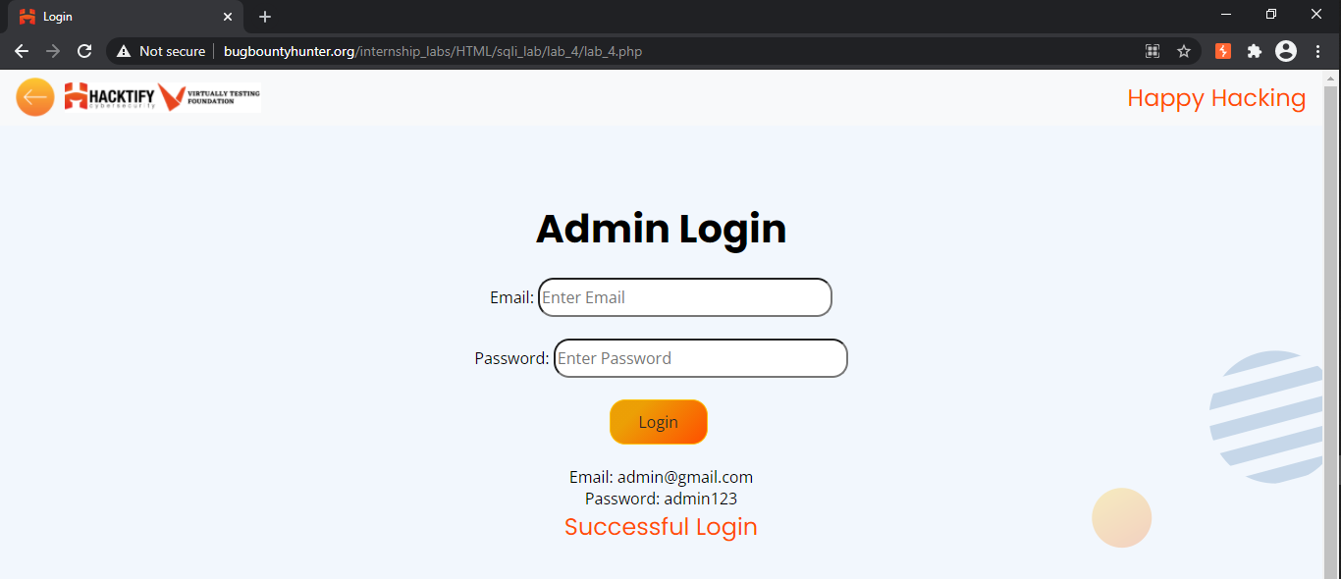

1.5. {Booleans and Blind!}

Reference | Risk Rating
Booleans and Blind! | Hard
Tools Used
Google Chrome, Burp Suite, SQL injection tool
Vulnerability Description
I found this vulnerability by entering and manipulating the URL by malicious SQL code.
How It Was Discovered
Automated Tools and Manual Analysis were both used to find this vulnerability.
Vulnerable URLs
https://www.bugbountyhunter.org/internship_labs/HTML/sqli_lab/lab_5/lab_5.php?id=1%20and%201=1
Consequences of not Fixing the Issue
Stealing credentials, access to the database, altering or modifying data, access to the network.
Suggested Countermeasures
Using stored procedures instead of dynamic SQL, prepared statements, least privilege access and input validation, character escaping, vulnerability scanner, firewall.
References
https://owasp.org/www-community/attacks/SQL_Injection

Proof of Concept
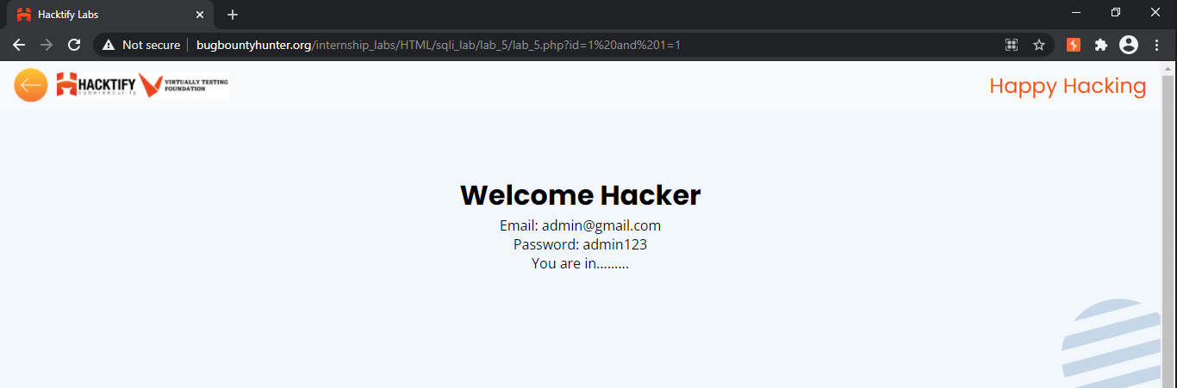

1.6. {Error based:Tricked}

Reference | Risk Rating
Error based:Tricked | Medium
Tools Used
Google Chrome, Burp Suite, SQL injection tool
Vulnerability Description
I found this vulnerability by entering malicious sql injection code into user input fields and successfully found user input fields vulnerable.
How It Was Discovered
Automated Tools and Manual Analysis were both used to find this vulnerability.
Vulnerable URLs
https://www.bugbountyhunter.org/internship_labs/HTML/sqli_lab/lab_6/lab_6.php
Consequences of not Fixing the Issue
Stealing credentials, access to the database, altering or modifying data, access to the network.
Suggested Countermeasures
Using stored procedures instead of dynamic SQL, prepared statements, least privilege access and input validation, character escaping, vulnerability scanner, firewall.
References
https://portswigger.net/web-security/sql-injection

Proof of Concept
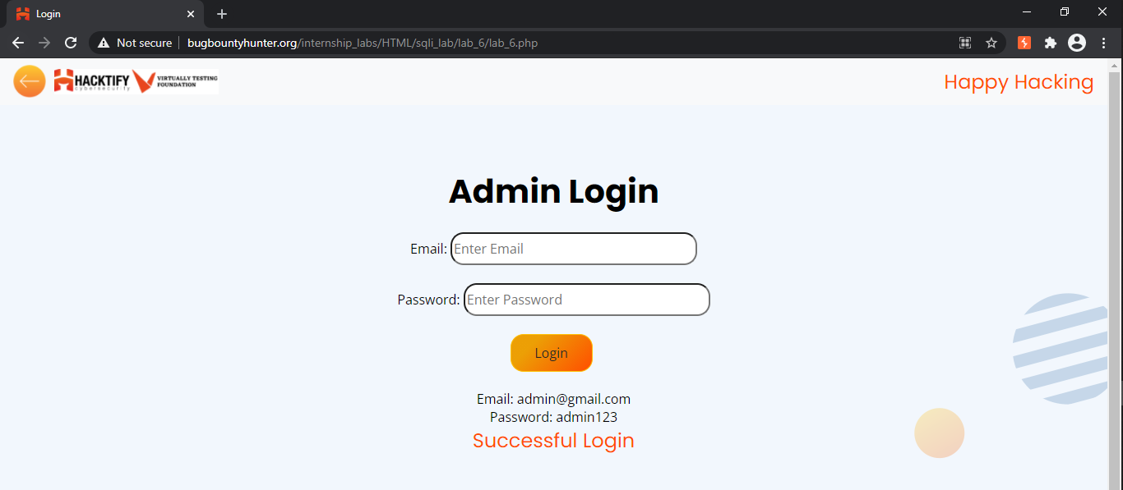

1.7. {Errors and Post!}

Reference | Risk Rating
Errors and Post! | Low
Tools Used
Google Chrome, Burp Suite, SQL injection tool
Vulnerability Description
I found this vulnerability by entering malicious sql injection code into user input fields and successfully found user input fields vulnerable.
How It Was Discovered
Automated Tools and Manual Analysis were both used to find this vulnerability.
Vulnerable URLs
https://www.bugbountyhunter.org/internship_labs/HTML/sqli_lab/lab_7/lab_7.php
Consequences of not Fixing the Issue
Stealing credentials, access to the database, altering or modifying data, access to the network.
Suggested Countermeasures
Using stored procedures instead of dynamic SQL, prepared statements, least privilege access and input validation, character escaping, vulnerability scanner, firewall.
References
https://owasp.org/www-community/attacks/SQL_Injection

Proof of Concept
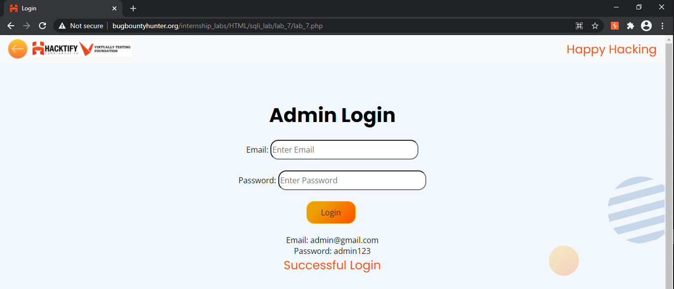

1.8. {Use agents lead us!}

Reference | Risk Rating
Use agents to lead us! | Hard
Tools Used
Google Chrome, Burp Suite, SQL injection tool
Vulnerability Description
I found this vulnerability by intercepting a login request into burp suite and taking it to the repeater and manipulating the user agent field with malicious SQL code to get successful in the SQL Injection attack.
How It Was Discovered
Automated Tools and Manual Analysis were both used to find this vulnerability.
Vulnerable URLs
https://www.bugbountyhunter.org/internship_labs/HTML/sqli_lab/lab_8/lab_8.php
Consequences of not Fixing the Issue
Stealing credentials, access to the database, altering or modifying data, access to the network.
Suggested Countermeasures
Using stored procedures instead of dynamic SQL, prepared statements, least privilege access and input validation, character escaping, vulnerability scanner, firewall.
References
https://portswigger.net/web-security/sql-injection

Proof of Concept
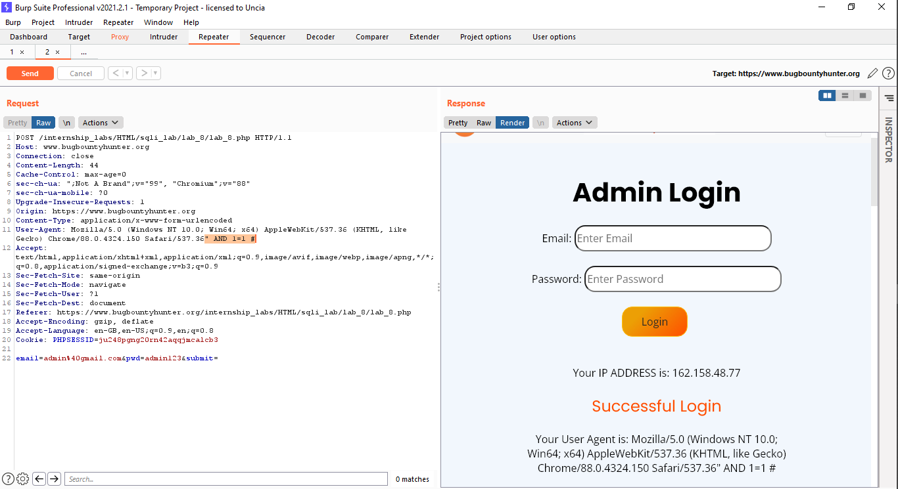

1.9. {Referer lead us!}

Reference | Risk Rating
Referer lead us! | Medium
Tools Used
Google Chrome, Burp Suite, SQL injection tool
Vulnerability Description
I found this vulnerability by intercepting a login request into burp suite and taking it to the repeater and manipulating the referer field with malicious SQL code to get successful in the SQL Injection attack.
How It Was Discovered
Automated Tools and Manual Analysis were both used to find this vulnerability.
Vulnerable URLs
https://www.bugbountyhunter.org/internship_labs/HTML/sqli_lab/lab_9/lab_9.php
Consequences of not Fixing the Issue
Stealing credentials, access to the database, altering or modifying data, access to the network.
Suggested Countermeasures
Using stored procedures instead of dynamic SQL, prepared statements, least privilege access and input validation, character escaping, vulnerability scanner, firewall.
References
https://owasp.org/www-community/attacks/SQL_Injection

Proof of Concept
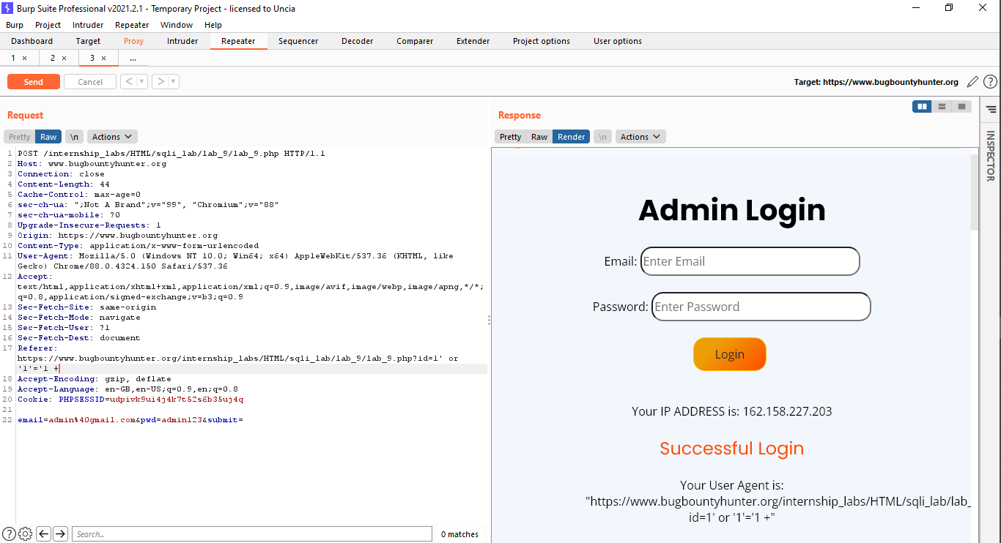

1.10. {Oh Cookies!}

Reference | Risk Rating
Oh Cookies! | Hard
Tools Used
Google Chrome, Burp Suite, SQL injection tool
Vulnerability Description
I found this vulnerability by entering and manipulating the URL by malicious SQL code.
How It Was Discovered
Automated Tools and Manual Analysis were both used to find this vulnerability.
Vulnerable URLs
https://www.bugbountyhunter.org/internship_labs/HTML/sqli_lab/lab_10/lab_10.php
Consequences of not Fixing the Issue
Stealing credentials, access to the database, altering or modifying data, access to the network.
Suggested Countermeasures
Using stored procedures instead of dynamic SQL, prepared statements, least privilege access and input validation, character escaping, vulnerability scanner, firewall.
References
https://portswigger.net/web-security/sql-injection

Proof of Concept
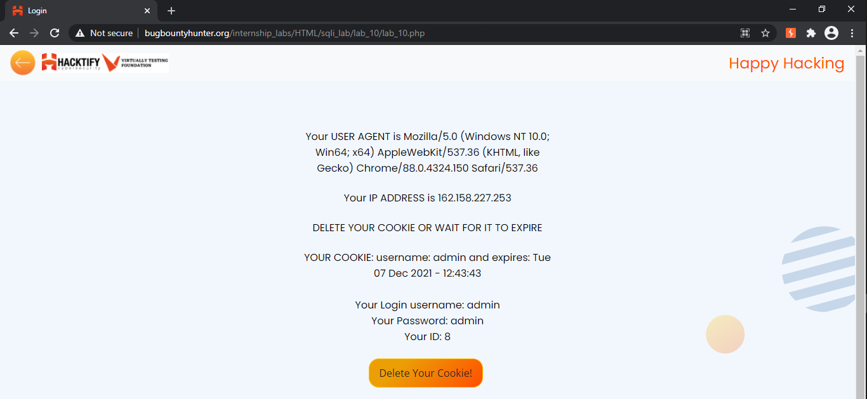

1.11. {WAF’s Are Injected!}

Reference | Risk Rating
WAF’s Are Injected! | Hard
Tools Used
Google Chrome, Burp Suite, SQL injection tool
Vulnerability Description
I found this vulnerability by entering and manipulating the URL by malicious SQL code.
How It Was Discovered
Automated Tools and Manual Analysis were both used to find this vulnerability.
Vulnerable URLs
https://www.bugbountyhunter.org/internship_labs/HTML/sqli_lab/lab_11/lab_11.php?id=1
Consequences of not Fixing the Issue
Stealing credentials, access to the database, altering or modifying data, access to the network.
Suggested Countermeasures
Using stored procedures instead of dynamic SQL, prepared statements, least privilege access and input validation, character escaping, vulnerability scanner, firewall.
References
https://owasp.org/www-community/attacks/SQL_Injection

Proof of Concept
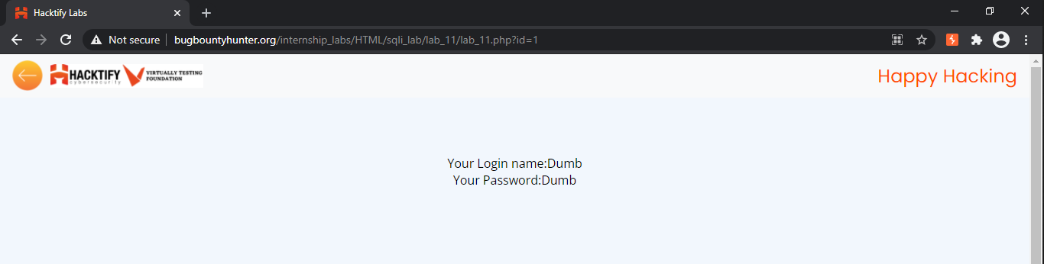

1.12. {WAF’s Are Injected Part2!}

Reference | Risk Rating
WAF’s Are Injected Part2! | Medium
Tools Used
Google Chrome, Burp Suite, SQL injection tool
Vulnerability Description
I found this vulnerability by entering and manipulating the URL by malicious SQL code.
How It Was Discovered
Automated Tools and Manual Analysis were both used to find this vulnerability.
Vulnerable URLs
https://www.bugbountyhunter.org/internship_labs/HTML/sqli_lab/lab_12/lab_12.php?id=4
Consequences of not Fixing the Issue
Stealing credentials, access to the database, altering or modifying data, access to the network.
Suggested Countermeasures
Using stored procedures instead of dynamic SQL, prepared statements, least privilege access and input validation, character escaping, vulnerability scanner, firewall.
References
https://portswigger.net/web-security/sql-injection

Proof of Concept
